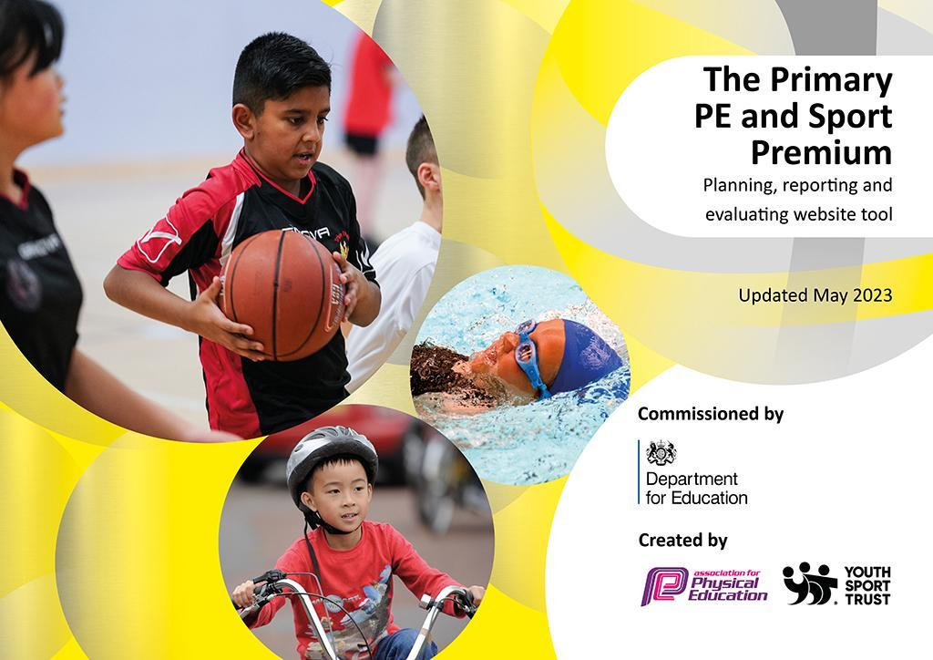
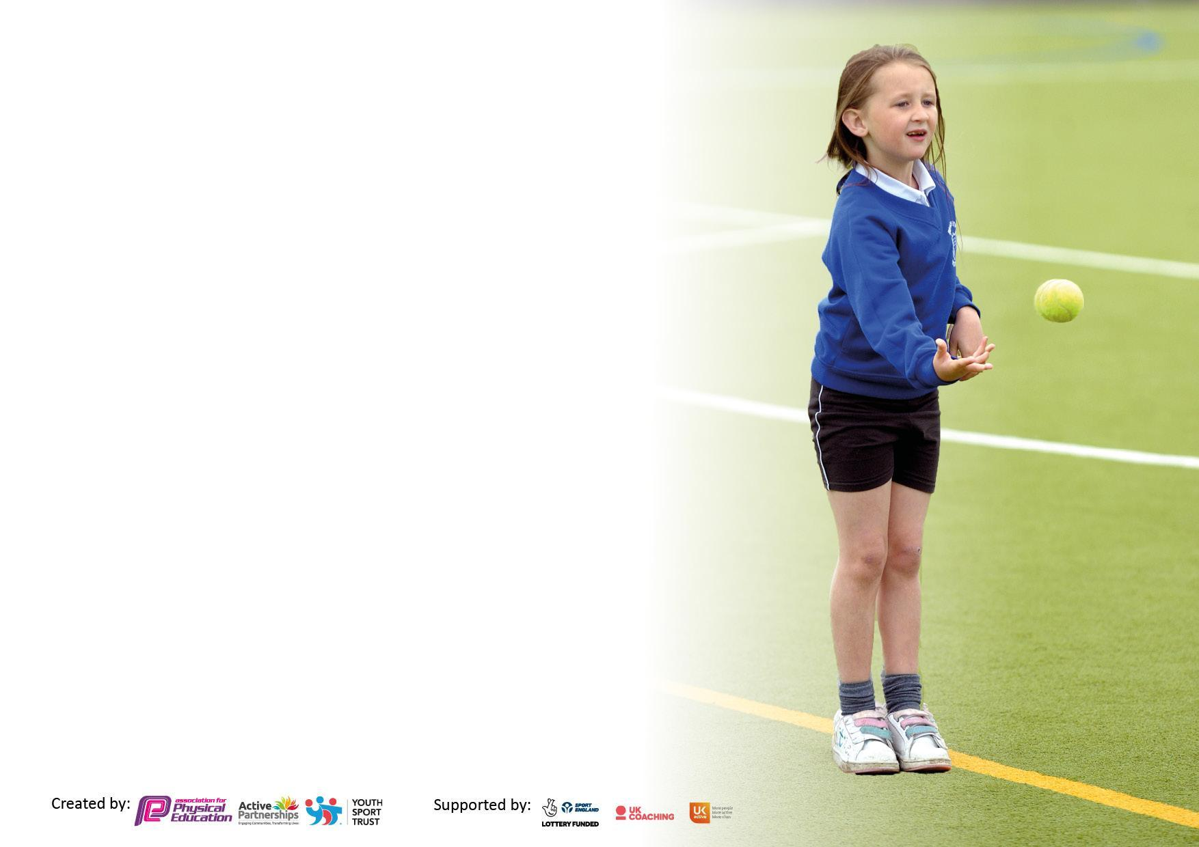

It is important that your grant is used effectively and based on school need. The Education Inspection Framework makes clear there will be a focus on ‘whether leaders and those responsible for governors all understand their respective roles and perform these in a way that enhances the effectiveness of the school’.

Under the Quality of Education Ofsted inspectors consider:
Intent - Curriculum design, coverage and appropriateness
Implementation - Curriculum delivery, Teaching (pedagogy) and Assessment
Impact - Attainment and progress

To assist schools with common transferable language this template has been developed to utilise the same three headings which should make your plans easily transferable between working documents.

Schools must use the funding to make additional and sustainable improvements to the quality of Physical Education, School Sport and Physical Activity (PESSPA) they offer. This means that you should use the Primary PE and sport premium to:

- Develop or add to the PESSPA activities that your school already offer
- Build capacity and capability within the school to ensure that improvements made now will benefit pupils joining the school in future years
- The Primary PE and sport premium should not be used to fund capital spend projects; the school’s budget should fund these.

Pleasevisitgov.ukfortherevisedDfEguidanceincludingthe5keyindicatorsacrosswhichschoolsshoulddemonstrate animprovement.Thisdocumentwillhelpyoutoreviewyourprovisionandtoreportyourspend.DfEencouragesschools to use this template as an effective way of meeting the reporting requirements of the Primary PE and Sport Premium.

We recommend you start by reflecting on the impact of current provision and reviewing the previous spend.

Schools are required to publish details of how they spend this funding, including any under-spend from 2021/2022, as well as on the impact it has on pupils’ PE and sport participation and attainment. All funding must be spent by 31st July 2023.

We recommend regularly updating the table and publishing it on your website throughout the year. This evidences your ongoing self-evaluation of how you are using the funding to secure maximum, sustainable impact. Final copy must be posted on your website by the end of the academic year and no later than the 31st July 2023. To see an example of how to complete the table please click HERE.
Details with regard to funding
Please complete the table below.

Total amount carried over from 2021/22 | £
Total amount allocated for 2021/22 | £
How much (if any) do you intend to carry over from this total fund into 2022/23? | £6,159.11
Total amount allocated for 2022/23 | £16,800
Total amount of funding for 2023/23. To be spent and reported on by 31st July 2023. | £22,959
Swimming Data
Please report on your Swimming Data below.

Meeting national curriculum requirements for swimming and water safety.

N.B. Complete this section to your best ability. For example you might have practised safe self-rescue techniques on dry land which you can then transfer to the pool when school swimming restarts.
Due to exceptional circumstances priority should be given to ensuring that pupils can perform safe self rescue even if they do not fully meet the first two requirements of the NC programme of study
What percentage of your current Year 6 cohort swim competently, confidently and proficiently over a distance of at least 25 metres?  N.B. Even though your pupils may swim in another year please report on their attainment on leaving primary school at the end of the summer term 2022.  Please see note above | 90%
What percentage of your current Year 6 cohort use a range of strokes effectively [for example, front crawl, backstroke and breaststroke]?  Please see note above | %
What percentage of your current Year 6 cohort perform safe self-rescue in different water-based situations? | %
Schools can choose to use the Primary PE and sport premium to provide additional provision for swimming but this must be for activity over and above the national curriculum requirements. Have you used it in this way? | No

Action Plan and Budget Tracking
Capture your intended annual spend against the 5 key indicators. Clarify the success criteria and evidence of impact that you intend to measure to evaluate for pupils today and for the future.

Academic Year: 2022/23 | Total fund allocated: £22959 | Date Updated: July 2023
Key indicator 1: The engagement of all pupils in regular physical activity – Chief Medical Officers guidelines recommend that primary school pupils undertake at least 30 minutes of physical activity a day in school |  |  |  | Percentage of total allocation:
 |  |  |  | %
Intent | Implementation |  | Impact
Your school focus should be clear what you want the pupils to know and be able to do and about  what they need to learn and to  consolidate through practice: | Make sure your actions to achieve are linked to your intentions: | Funding allocated: | Evidence of impact: what do pupils now know and what can they now do? What has changed?: | Sustainability and suggested next steps:
All pupils at Carlton Primary will have a positive and passionate attitude towards physical activity, being lifelong advocates, knowing its importance for a healthy lifestyle. We encourage children to engage in as much physical activity as possible. The curriculum aims to invigorate the mind as well as the body; a healthy mind is equally as important as a healthy body. | Get set 4 PE whole school curriculum  AFPE membership  IPads  PA System  4 Corner Coaching | £1237  £63  £2222.50  £260  £3060 | Children have a broad and inspiring curriculum to encourage a positive attitude towards school sports and PE. The iPad enable children to record and evaluate their own work and performances. The use of the PA system continues to have a positive impact on the children’s physical, mental health and well being as they are able to participate in regular aerobics assemblies to boost confidence, stamina and fitness levels. | To continue to encourage regular physical activity throughout the school day.
Key indicator 2: The profile of PESSPA being raised across the school as a tool for whole school improvement |  |  |  | Percentage of total allocation:
 |  |  |  | %
Intent | Implementation |  | Impact
Your school focus should be clear what you want the pupils to know and be able to do and about  what they need to learn and to  consolidate through practice: | Make sure your actions to achieve are linked to your intentions: | Funding allocated: | Evidence of impact: what do pupils now know and what can they now do? What has changed?: | Sustainability and suggested next steps:
To be physically literate, so that they can apply their physical skills to a wide variety of activities throughout their lives. | Membership to Bedford School Sports Partnerships  Premier Sport | £3780  £450, £825, £900 | Children have thoroughly enjoyed participating in a range of different sporting activities, extracurricular clubs and experiences. | Participate in the Bedford School Sports partnership in the next academic year.

Key indicator 3: Increased confidence, knowledge and skills of all staff in teaching PE and sport |  |  |  | Percentage of total allocation:
 |  |  |  | %
Intent | Implementation |  | Impact
Your school focus should be clear | Make sure your actions to | Funding | Evidence of impact: what do | Sustainability and suggested
what you want the pupils to know | achieve are linked to your | allocated: | pupils now know and what | next steps:
and be able to do and about | intentions: |  | can they now do? What has
what they need to learn and to |  |  | changed?:
consolidate through practice:
To ensure staff are up to date with training and are offered a range of CPD opportunities on increase confidence. | CPD opportunities through the Bedford SSP.  Swimming CDP  PE conference | £see indicator 2  £348  £180 | Teachers have participated in CPD for Gymnastics and swimming, this has helped to build confidence in these areas. | Transfer skills from CPD this year to teaching next year.
Key indicator 4: Broader experience of a range of sports and activities offered to all pupils |  |  |  | Percentage of total allocation:
Intent | Implementation |  | Impact
Your school focus should be clear | Make sure your actions to | Funding | Evidence of impact: what do | Sustainability and suggested
what you want the pupils to know | achieve are linked to your | allocated: | pupils now know and what | next steps:
and be able to do and about | intentions: |  | can they now do? What has
what they need to learn and to |  |  | changed?:
consolidate through practice:
Additional achievements:  To offer children a broad range of new experiences and activities. | Forest school training and equipment.  Tents  Yoga | £1900, £166, £875  £812  £250 | Children have grown in confidence and enjoyed experiencing a range of new outdoor activities.  Children have gained new valuable skills and knowledge. | To continue to build on the Forest school resources, equipment and areas.

Key indicator 5: Increased participation in competitive sport |  |  |  | Percentage of total allocation:
 |  |  |  | %
Intent | Implementation |  | Impact
Your school focus should be clear | Make sure your actions to | Funding | Evidence of impact: what do | Sustainability and suggested
what you want the pupils to know | achieve are linked to your | allocated: | pupils now know and what | next steps:
and be able to do and about | intentions: |  | can they now do? What has
what they need to learn and to |  |  | changed?:
consolidate through practice:
To be able to work in a variety of team situations, showing cooperation, communication, determination, resilience, leadership, the ability to evaluate and improve and most importantly to have fun.  To also give all children an opportunity to participate in competitions and competitive sports. Membership to the Bedford School Sports Partnership | Membership to the Bedford School Sports Partnership | £ see indicator 2 | Pupils look forward to competitions and have a good understanding of the values and expectations at competitions. They have shown a keen interest in a variety of sports and some have taken part in more sports. | To continue to attend sports competitions and festivals next academic year and build upon the children’s confidence in sporting activities.

Signed off by
Head Teacher:
Date: | July 2023
Subject Leader:
Date:
Governor:
Date:

