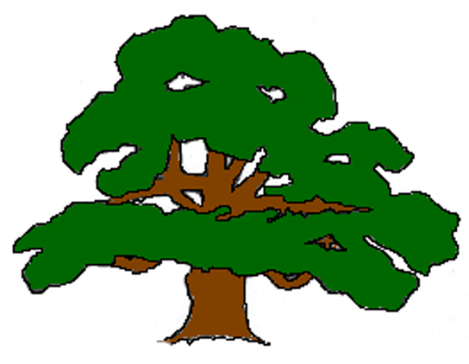Carlton VC Primary School
DEVELOPMENTAL STAGES OF DRAWING

1 – 2 years | 2 – 3 years | 3 -4 years | 4 -5 years | 5-6 years | 6 – 7 years
Random Scribble | Controlled scribble | Basic Shapes | Patterns & tadpole people | Pictures and Portraits | Interests and Experience
This stage is about exploring and developing motor coordination.  Around 15 to 18 months babies begin to develop uncontrolled scribbles that don’t represent anything.  Drawing is really about learning about cause and effect, enjoying their movements and the effects of them.  Their scribbles enable them to learn about the properties of objects, materials and tools such as pencils, pens, paint, crayons and paper. | Characterized by spontaneous circular or to-and-fro scribbles and dots.  Toddlers begin to make drawings that include:  - horizontal and vertical lines  - multiple loops and spirals  - roughly drawn circles  - shapes that resemble letters T and V  Children begin to discover the connection between the movements they make and the marks that form on the paper. They will begin to repeat movements on purpose. | fine motor control and hand-eye coordination improve basic shapes are included.  - circles & squares  - crosses  - dots  - shapes that resemble letters T, V and H  - Colour is unrealistic  - Head and legs people no face  They usually name their picture while drawing it or after it is complete, but they do not start a drawing with a clear plan for what they will draw. | - patterns start emerging  - A child will make a pattern and interpret it as a representation of something, giving it a label.  Drawings include:  - Squares, circles and rectangles  - Attempts triangles and diamonds, although they may not be able to form them yet  - Crosses  - Letters (pretend writing)  - Tadpole people start to have faces, eyes initially.  They draw not what they see, but what they know, and will add details as they become important to them.  Drawing takes on more meaning and intention. | begin to show much creativity in their drawings.  Drawings include:  - Basic shapes  - Triangles and diamonds  - Spontaneous letters (to imitate writing)  - Drawing of a person with details  Children will now draw spontaneously and begin to show their own backgrounds, interests and experiences in their drawings. They draw what they know.  Their representation of people, animals and houses changes constantly.  They will also name their picture before beginning.  They usually place themselves in the middle of a drawing due to their egocentric nature. | Children have their own style of drawing, which can usually be recognized by adults.  - they can form good circles, squares, rectangles, triangles and diamonds in their drawings.  - they usually settle on a certain representation of a person and tends to draw them all with the same basic shape.  - Drawings represent all kinds of animals and things, usually those that interest them the most.  - They show their higher level of cognition by drawing objects on a baseline.  The way they see the world comes through their drawings. They leave out unimportant things and enlarge things that are important to them.
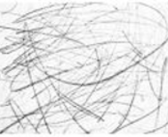 | 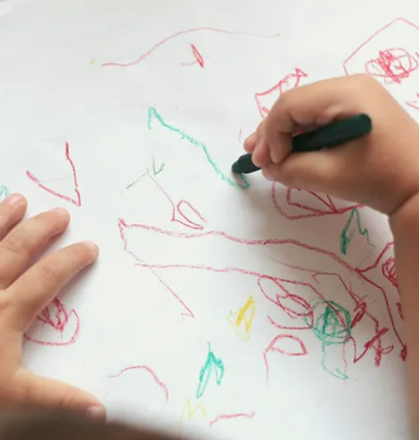 | 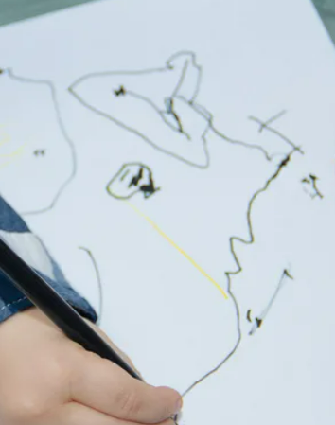 | 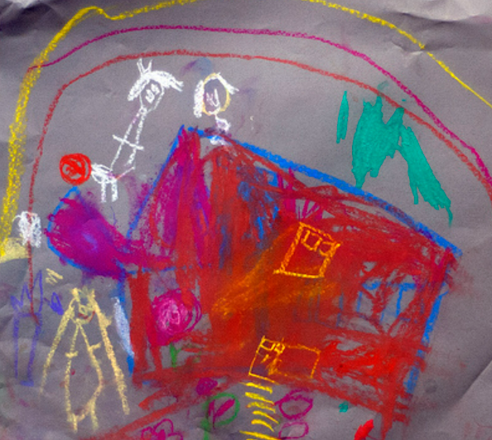 | 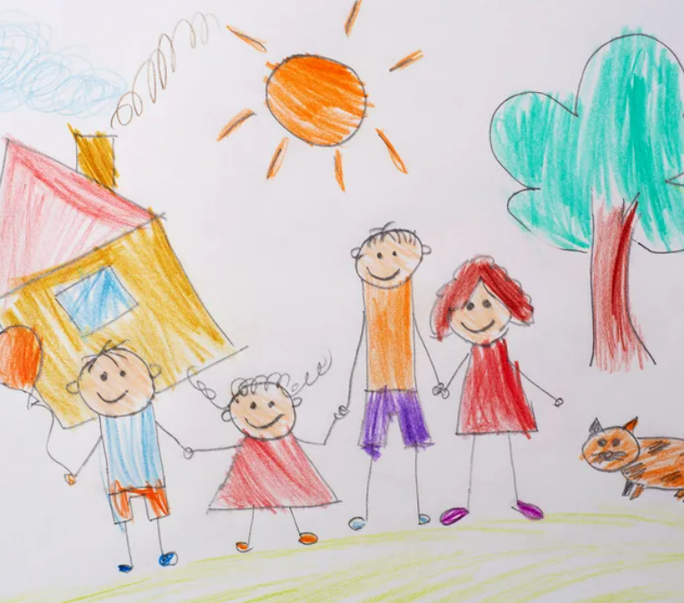 | 

