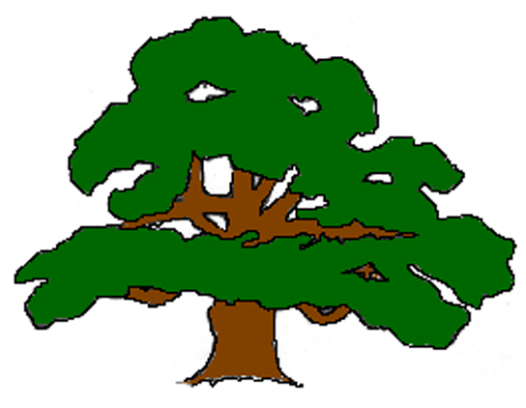Carlton VC Primary School
DEVELOPMENTAL STAGES OF PRE-WRITNG
Visual Motor Integration
These are the average ages that children may be able to make these shapes they are not a developmental goal.
1 to 2 years | 2 years | 2 years 6 months | 3 years | 4 years | 4 years  4 months | 4 years  6 Months | 4 years  7 months | 4 years  11 months | 5 Years  3 Months
Scribble | Vertical Line | Horizontal line | Circle | Vertical and horizontal cross | Square | Diagonal Line  Right to left | Diagonal line  Left to right | Diagonal cross | Triangle
Child enjoys making random marks on the paper but they are uncontrolled | The vertical line is drawn first because it does not require crossing the midline of the body. | At two and a half, children will start crossing midline and creating a horizontal line. | At three years, they start to draw a full circle. At two and a half, you might see circular scribbles, but you see a perfect circle at three years. | At three and a half to four years, they can make the two steps of the cross | Four years old is when they can start to really draw an accurate square. At three and three and a half, they might imitate a square, but a lot of times, it will have curved corners and not distinct corners for a square. | Diagonal lines, come into play at about four and a half years old. |  | They then begin to combine the diagonal lines to create the x shape. | Finally, they can put it all together to make a triangle at five years old.
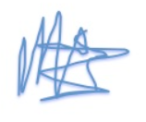 | 

