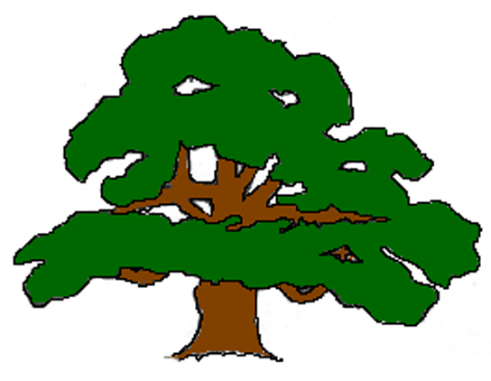Carlton VC Primary School
DEVELOPMENTAL STAGES OF SCISSOR SKILLS

1.5 -2.5 years | 2 – 3 years | 3 Years | 3 – 3.5 years | 4 – 4.5 years | 4.5 – 5 years | 5 -6 years
Two Hand Grip | One handed snipping | Snips Paper Moving Forward | Helper hand | Curved lines | Cuts a Square Shape | Cuts complex shapes
Between the ages of 1.5 to 2 years old, a child learns to hold scissors, often using both hands to open and close the blades.  2 to 2.5 years old || Open/Closes Scissors  At ages 2-2.5 years old, a child learns how to open and close the scissors. They are NOT ready to use them with paper. This is a great time to practice with play dough, modelling clay, or continue to practice tearing paper. | Holding scissors and snipping paper.  Once the child has mastered opening and closing the scissors, they can move on to making small snips on the paper. They are not moving forward on the paper with scissors, just making snips. | Moving scissors forward while cutting a longer area.  By the time a child hits age 3, they are able to make snips on the paper while moving the scissor forward across the paper.  You can also start encouraging the use of the helper hand to hold the paper while cutting.  Cutting hand position | Begins to use their “helper hand” or non-dominant hand to hold the paper and help manipulate it while cutting with their dominant hand.  Remember to encourage a “thumbs up” position while holding both the paper and scissors  Can move the scissors along a straight line that is 6 inches long. Their accuracy is still a work in progress, with most cutting within 2cm of the cutting line. | Accuracy improves and they are able to cut a 6-inch straight line within 1cm of the cutting line.  Able to cut on a curved line relatively close to the drawn line.  Once they have mastered curved lines, they are able to take on circle shapes. | Between the ages of 4.5 and 5 years old, a child can cut out a square shape relatively close to the line. | Between the ages of 5-6, a child can begin to cut out more complex shapes such as figures.  From this point on children gradually improve their accuracy.
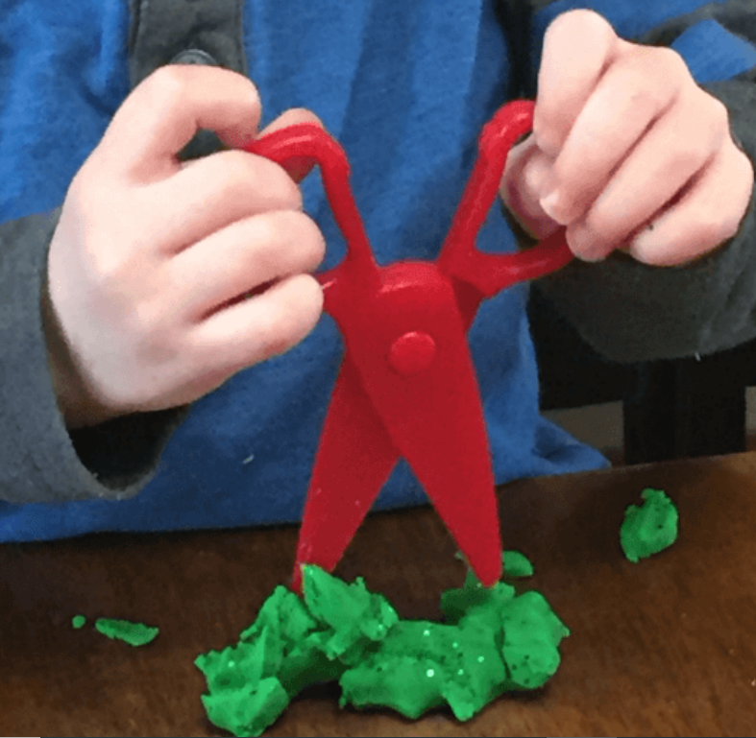 | 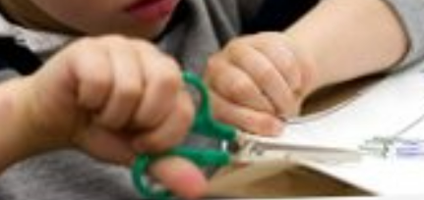 |  | 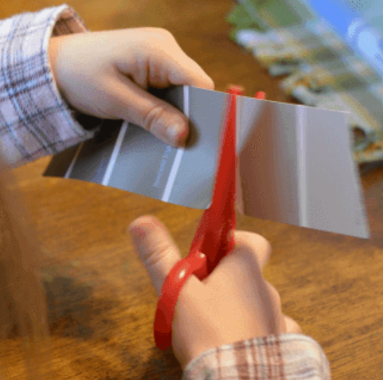 | 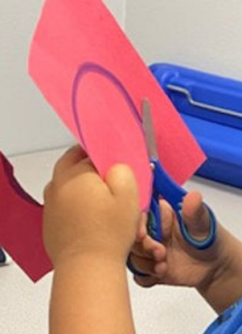 | 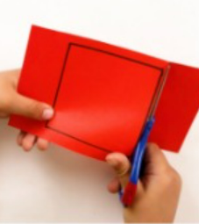 | 

