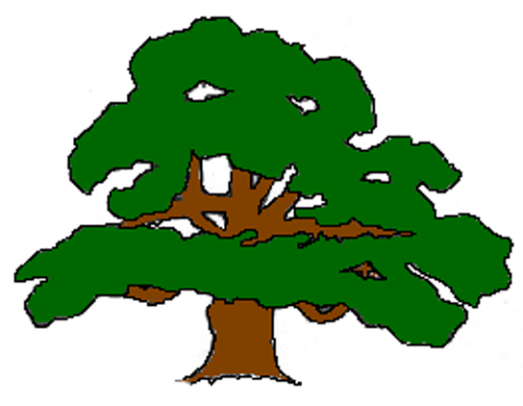Carlton VC Primary School
PROGRESSION OF SKILLS IN WRITING - EYFS
Writing is a complex process and involves the combination of a variety of skills including: motor skills, phonological awareness, communication and language skills, PSED skills, special awareness etc. This document should not be used in isolation but as a part of a much bigger whole. Please also refer to our other progression documents and Birth to 5 matters. Remember that children do not develop within subject areas but in a wholistic and multidisciplinary way. Success in writing is only possible if success in all other areas is promoted and valued too.
Range 3 –  16 to 26 months | Range 4 –  2 to 3 years | Range 5 - Three to Four Years | Range 6 – 4 to 5 years - Reception | Writing- ELG
As toddlers develop, they increase their understanding of how their marks are symbolic and convey meaning. Their marks may not yet resemble letters and words but nonetheless may carry meaning for the child.  - Begins to understand the cause and effect of their actions in mark making  - Knows that the marks they make are of value  - Enjoys the sensory experience of making marks  Handwriting –  PD - Moving and Handling  - Hands start to operate independently during a task that uses both, with each hand doing something different at the same time (e.g. holding a block in one hand and steadying the other block with the other hand.  - When holding crayons, chalks etc, makes connections between their movement and the marks they make | - Distinguishes between the different marks they make.  - Enjoys drawing and writing on paper, on screen and on different textures, such as in sand or playdough and through using touch-screen technology  Handwriting – PD - Moving and Handling  - Sits comfortably on a chair with both feet on the ground  - May be beginning to show preference for dominant hand.  - Shows increasing control in holding, using and manipulating a range of tools and objects including mark making tools  - Holds mark-making tools with thumb and all fingers | - Makes up stories, play scenarios, and drawings in response to experiences, such as outings  - Sometimes gives meaning to their drawings and paintings  - Ascribes meanings to signs, symbols and words that they see in different places, including those they make themselves  - Includes mark making and early writing in their play  - Imitates adults’ writing by making continuous lines of shapes and symbols (early writing) from left to right  - Attempts to write their own name, or other names and words, using combinations of lines, circles and curves, or letter-type shape  - Shows interest in letters on a keyboard, identifying the initial letter of their own name and other familiar words  - Begins to make letter-type shapes to represent the initial sound of their name and other familiar words  Handwriting - PD - Moving and Handling  - Creates lines and circles pivoting from the shoulder and elbow  - Manipulates a range of tools and equipment in one hand, tools include paintbrushes, scissors, hairbrushes, toothbrush, scarves or ribbons | - Enjoys creating texts to communicate meaning for an increasingly wide range of purposes, such as making greetings cards, tickets, lists, invitations and creating their own stories and books with images and sometimes with words, in print and digital formats  - Gives meaning to the marks they make as they draw, write, paint and type using a keyboard or touch-screen technology  - Begins to break the flow of speech into words, to hear and say the initial sound in words and may start to segment the sounds in words and blend them together  - Starts to develop phonic knowledge by linking sounds to letters, naming and sounding some of the letters of the alphabet, identifying letters and writing recognisable letters in sequence, such as in their own name  - Uses their developing phonic knowledge to write things such as labels and captions, later progressing to simple sentences  Development Matters – Reception - Writing  - Form lower-case and capital letters correctly.  - Spell words by identifying the sounds and then writing the sound with letter/s.  - Re-read what they have written to check that it makes sense.  - Write short sentences with words with known letter-sound correspondences using a capital letter and full stop.  Handwriting – PD - Moving and Handling  - Shows a preference for a dominant hand  - Begins to use anticlockwise movement and retrace vertical lines  - Begins to form recognisable letters independently  - Uses a pencil and holds it effectively to form recognisable letters, most of which are correctly formed. | - Write recognisable letters, most of which are correctly formed.  - Spell words by identifying sounds in them and representing the sounds with a letter or letters.  - Write simple phrases and sentences that can be read by others.  Handwriting  - Hold a pencil effectively in preparation for fluent writing- using the tripod grip in almost all cases.  FMS-ELG

Early Steps  Making Marks | - I explore making marks, but I do not communicate meaning.  - Random scribbling.  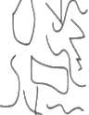 |  | - I draw basic pictures.  - I use lines to look like writing. Scribble writing  - Left to right direction  - I begin to assign meaning.  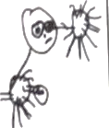  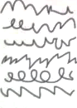 |  |  |  | - I write symbols and shapes that look like writing.  - I assign meaning to the marks  - Attempts to write name  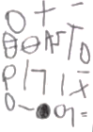 |  | - I write random letters but there is no connection between letters and sounds. I talk about my writing and give meaning.  - Writes name from memory  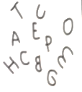 |  |  |  | - I use letter strings which travel from left to right and top to bottom.  - I attempt to ‘read’ my writing.  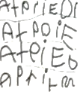 |  |  | - I write letters with spaces between them to resemble the idea of words.  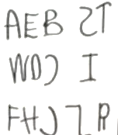 |  | - I copy words that I see in the environment around me.  - I often do not know what the words say.  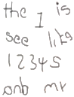
Developing Writing  Words | - I am beginning to hear initial sounds and attempt to write these down.  m - mum  letter for name |  |  | - I can hear initial sounds in words and write the letters down to match.  c - cat  d- dog  p - pig |  | - I can write short strings of letters to represent words. Two or three letters in sequence.  - Hearing dominant sounds  - Hearing /writing final sounds first, and then medial.  - Left to right.  Rbt - rabbit  Baln - balloon |  |  |  | - I can spell out and write down vc cvc words by matching letters and sounds.  at in up  cat  dog  pig |  | - I can write High Frequency decodable words  - I can write tricky words from memory.  mum dad. and can  I go to the no into |  |  | - I can spell out words with taught:  - consonant clusters  - digraphs  - trigraphs  - I make phonically plausible attempts at more difficult words using taught GPCs  buzz fill mess  ship. chip thing rush  boat sheep now soil |  |  |  | - I write more challenging words with taught sounds at level 2, 3 and 4 phonics.  - Plausible attempts at longer words with more syllables  - I write level 2,3, & 4 tricky words.
Developing Writing  Sentences | - I can formulate and say a simple sentence for writing. | - I can orally compose a sentence and hold it in my memory before I start to write it.  Repeats & recalls |  |  | - I can write a series of beginning letters and sounds for my phrase.  - There may be no spaces between words.  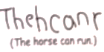  - Begins to be readable to others |  |  | - I can recall the order of words in my sentence.  - I start to put finger spaces between my words and to use known words. Writing is readable.  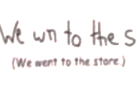  - I start to read my sentence |  |  | - I can write a sentence with a full stop and capital letter.  - I can re-read it and check that it makes sense.  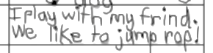  - Others can read my sentence. |  |  | - I can write spaces between all the words in my sentences.  - Some punctuation may be used.  - Medial and end sounds evident including vowels in my spellings.  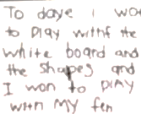 |  |  | - I can write two or more sentences using real spellings and silent letters. Most sentences have the correct beginning and end punctuation.  

